Civil War women’s shoes
The Rose, Civil War, black- smooth 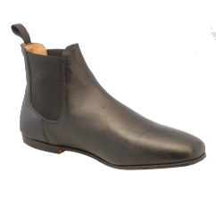

Named for the famous Confederate spy and patriot, Rose Greenhow, this is another elastic-sided shoe. It has a plain, tapered squarish toe and a vamp much like a fine English riding boot or jodhpur. Designed to be comfortable for outdoor wear, it is a fine shoe for the active lady, whether period-correct event watcher, nurse or sweetheart. We called this model Rose with a vision of a dedicated lady making her way over the uncertain ground between Federal and Confederate lines. Rose is leather lined and very well constructed. Rose looks good with today's slacks, too. Sizes 6M-11W full & half sizes. Price $103.15

Rose Greenhow is credited with furnishing the information that won the Battle of First Manassas. Captured and imprisoned, she somehow obtained her freedom and fled to Europe where she became a great social success, presented in several royal courts and raising funds for the Cause. She wrote a book about the War and raised support, money and sympathy for the Confederacy.

When the Blockade Runner which was returning her to the Confederacy was driven against the North Carolina shore by Federal blockaders, Rose attempted to reach land at Cape Fear in a small boat. The boat overturned and Rose Greenhow was pulled down to her death by the weight of the gold she was carrying.

Authenticity of style: "Shoes" by June Swann (page 48) shows an unfinished lady's shoe that was made by Spekes Hall and shown at the Great Exhibition in 1861. Elastic-side shoes remained in fashion until the 1880's.

Your welcome to Phone us at 1 800-605-8280 to order.

Victoria: black, smooth
Victoria is a fully leather lined flat heeled, fitted ankle-high bootee for the ladies. Victoria has a tapered, squarish toe cap and is made of soft leather on a left\right last.
Victoria has six jet black buttons on the front of the shoe but there is no need for a button hook. Victoria has two elastic gusset on the inside and a smaller one on the outside of the ankle.
Don't worry about time period or authenticity. The elastic gusset was patented in Britain in 1837 by the firm of Spekes Hall. (Victorian Costume and Costume Accessories, Anne Buck, keeper of the Gallery of English Costume, Platt Hall, Manchester. Library of Congress #62-8330)
The moment you hold Victoria you will know that you have a quality shoe in your hand. Comfort, quality and authenticity are all brought by Victoria.
Full and half sizes 6M to 11W price $103.15
Here is Fugawee's Victoria reproduction pictured with an original shoe from the Civil War era.

The original appears to be made of patent leather and is probably about size four. Note the flat heel and the buttons. Fugawee's Victoria took its more graceful toe cap from another original. Similar elastic-sided boots are shown in Godey's Ladies Book and June Swan's "Shoes". MS Swan, said by many to be the world's foremost expert on footwear, says that they were popular from 1855 to 1880. Some medium heel models were made but Fugawee decided on the flat heel to accommodate ladies who might find themselves walking on rough ground.
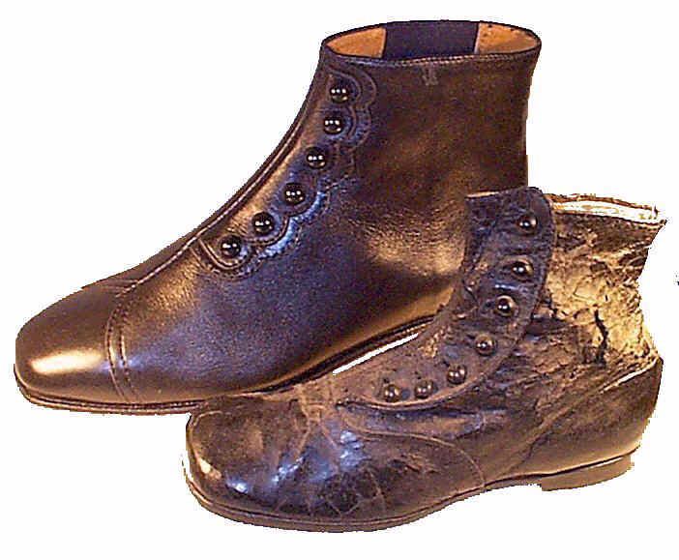

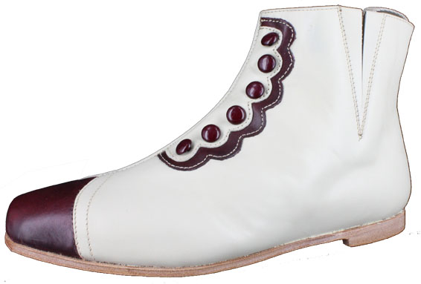

Sara, Civil War 2 gusset ankle boot.
Sara has white leather with Maroon toe, buttons and scallop trim. The Buttons are strictly ornamental as the boot slips on with elastic gussets. The leather heel is ¼”. Full and half sizes 6 to 12 regular and wide widths. Price $ 106.32
........................

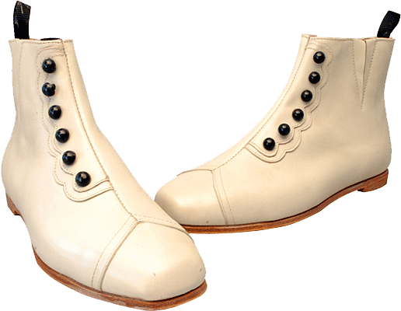

Victoria Civil War Women’s ankle boot in Bone color leather
The Victoria is something new for the Civil War ladies. The moment you hold Victoria you will know that you have a quality shoe in your hand. Comfort, quality and authenticity are all brought by Victoria.
Victoria is a fully leather lined flat heeled, fitted ankle-high bootee for the ladies. Victoria has a tapered, squarish toe cap and is made of soft leather on a left\right last. It has two elastic gussetts for easy access. The Black button accent the scalloped design. Full and half sizes 6M to 22W price $106.32
Don't worry about time period or authenticity. The elastic gusset was patented in Britain in 1837 by the firm of Spekes Hall. (Victorian Costume and Costume Accessories, Anne Buck, keeper of the Gallery of English Costume, Platt Hall, Manchester. Library of Congress #62-8330)
.....................
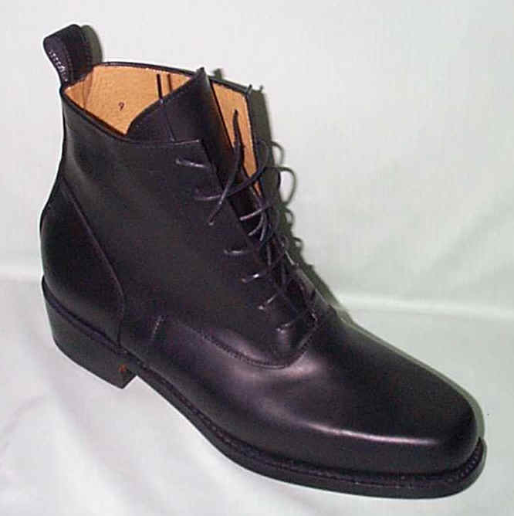Stella, Civil War women’s boot.
A ladies lace up boot, sturdy enough for around the camp and comfortable enough for all day. It has a amble toe with a soft curve, 7 lace up holes and a tab at the back, 1” leather heel and leather soles.
Sizes 5M to 11-1/2M, Black only, Price $149.48
..............................
Josie, Civil War Boot, black-smooth only 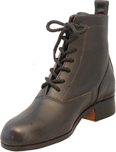
The Sister boot to the Stella with a slightly rounder toe and a bit shorter in the leg. The more feminine lines with a 1 ¼” heel. The softer leather, wider width gives its comfy feel. Full and half sizes 5 to 12W Price $ 166.16

